**TABLE OF CONTENTS**

**TABLE OF CONTENTS i LIST OF FIGURES iii LIST OF TABLES iv**

**1 EXPERIMENTAL PROCEDURE 1**

1.1 Master Alloy . . . . . . . . . . . . . . . . . . . . . . . . . . . . . . . . . . . . . . 1

1.1.1 Base Elements . . . . . . . . . . . . . . . . . . . . . . . . . . . . . . . . . 1

1.1.2 Induction Furnace . . . . . . . . . . . . . . . . . . . . . . . . . . . . . . 1

1.1.3 Crucibles . . . . . . . . . . . . . . . . . . . . . . . . . . . . . . . . . . . . 3

1.1.4 Melt Cycle . . . . . . . . . . . . . . . . . . . . . . . . . . . . . . . . . . . 4

1.1.5 Gravity Casting . . . . . . . . . . . . . . . . . . . . . . . . . . . . . . . . 4

1.1.6 Injection Casting . . . . . . . . . . . . . . . . . . . . . . . . . . . . . . . 5

1.2 Bulk Sample Manufacture . . . . . . . . . . . . . . . . . . . . . . . . . . . . . . 5

1.2.1 Gravity Casting . . . . . . . . . . . . . . . . . . . . . . . . . . . . . . . . 5

1.2.2 Injection Casting . . . . . . . . . . . . . . . . . . . . . . . . . . . . . . . 5

1.2.3 Sample Cutting . . . . . . . . . . . . . . . . . . . . . . . . . . . . . . . . 5

1.3 Semi-Crystalline Target Manufacture . . . . . . . . . . . . . . . . . . . . . . . . 6

1.3.1 Gravity Casting . . . . . . . . . . . . . . . . . . . . . . . . . . . . . . . . 6

1.3.2 Riser Removal . . . . . . . . . . . . . . . . . . . . . . . . . . . . . . . . . 7

1.3.3 Target Extraction . . . . . . . . . . . . . . . . . . . . . . . . . . . . . . . 7

1.3.4 Target Rounding . . . . . . . . . . . . . . . . . . . . . . . . . . . . . . . 7

1.3.5 Target Polishing . . . . . . . . . . . . . . . . . . . . . . . . . . . . . . . . 7

1.4 Crystalline Target Manufacture . . . . . . . . . . . . . . . . . . . . . . . . . . . 10

1.4.1 Gravity Casting . . . . . . . . . . . . . . . . . . . . . . . . . . . . . . . . 10

1.4.2 Sectioning of Targets . . . . . . . . . . . . . . . . . . . . . . . . . . . . . 10

1.4.3 Target Rounding . . . . . . . . . . . . . . . . . . . . . . . . . . . . . . . 11

1.4.4 Target Polishing . . . . . . . . . . . . . . . . . . . . . . . . . . . . . . . . 11

1.5 DC Magnetron Sputtering . . . . . . . . . . . . . . . . . . . . . . . . . . . . . . 11

1.5.1 DC Magnetron Sputtering . . . . . . . . . . . . . . . . . . . . . . . . . . 11

|  |  |  |  |  |  |  |  |  |  |  |  |  |  |  |  |  |  |  |  |  |  |  |  |  |  |  |  |  |  |  |  |  |  |  |  |  |  |  |
| --- | --- | --- | --- | --- | --- | --- | --- | --- | --- | --- | --- | --- | --- | --- | --- | --- | --- | --- | --- | --- | --- | --- | --- | --- | --- | --- | --- | --- | --- | --- | --- | --- | --- | --- | --- | --- | --- | --- |
|  | 1.5.2 Deposition of Films . . | | | | | | | | | . | . | . | . | . | . | . | . | . | . | . | . | . | . | . | . | . | . | . | . | . | . | . | . | . | . | . | . | 11 |
| 1.6 | Examined Substrates . . . . . | | | | | | | | | . | . | . | . | . | . | . | . | . | . | . | . | . | . | . | . | . | . | . | . | . | . | . | . | . | . | . | . | 13 |
|  | 1.6.1 Al DSC Lid Substrate . | | | | | | | | | . | . | . | . | . | . | . | . | . | . | . | . | . | . | . | . | . | . | . | . | . | . | . | . | . | . | . | . | 13 |
|  | 1.6.2 Silica Glass Substrate . | | | | | | | | | . | . | . | . | . | . | . | . | . | . | . | . | . | . | . | . | . | . | . | . | . | . | . | . | . | . | . | . | 13 |
| 1.6.3 | | Silicon Wafer Substrate . | | | | | | | | | . | . | . | . | . | . | . | . | . | . | . | . | . | . | . | . | . | . | . | . | . | . | . | . | . | . | . | 13 |
| 1.7 | Storage . . . . . . | | . | . | . | . | . | . | . | . | . | . | . | . | . | . | . | . | . | . | . | . | . | . | . | . | . | . | . | . | . | . | . | . | . | . | . | 13 |
|  | 1.7.1 Desiccator | | . | . | . | . | . | . | . | . | . | . | . | . | . | . | . | . | . | . | . | . | . | . | . | . | . | . | . | . | . | . | . | . | . | . | . | 14 |
| 1.8 | Characterisation . | | . | . | . | . | . | . | . | . | . | . | . | . | . | . | . | . | . | . | . | . | . | . | . | . | . | . | . | . | . | . | . | . | . | . | . | 14 |
| 1.8.1 Stylus profiler characterisation . . . . . . . . . . . . . . . . . . . . . . . 15 | | | | | | | | | | | | | | | | | | | | | | | | | | | | | | | | | | | | | | |
| 1.8.2 | | SEM characterisation . | | | | | | | | . | . | . | . | . | . | . | . | . | . | . | . | . | . | . | . | . | . | . | . | . | . | . | . | . | . | . | . | 15 |
| 1.8.3 | | EDS characterisation . | | | | | | | | . | . | . | . | . | . | . | . | . | . | . | . | . | . | . | . | . | . | . | . | . | . | . | . | . | . | . | . | 15 |
| 1.8.4 | | DSC characterisation . | | | | | | | | . | . | . | . | . | . | . | . | . | . | . | . | . | . | . | . | . | . | . | . | . | . | . | . | . | . | . | . | 15 |
| 1.8.5 | | XRD characterisation . | | | | | | | | . | . | . | . | . | . | . | . | . | . | . | . | . | . | . | . | . | . | . | . | . | . | . | . | . | . | . | . | 16 |
| 1.8.6 Nano-indentation characterisation . . . . . . . . . . . . . . . . . . . . . 16 | | | | | | | | | | | | | | | | | | | | | | | | | | | | | | | | | | | | | | |
| 1.8.7 | | AFM characterisation . | | | | | | | | | . | . | . | . | . | . | . | . | . | . | . | . | . | . | . | . | . | . | . | . | . | . | . | . | . | . | . | 17 |
| 1.8.8 | | FIB characterisation . . | | | | | | | | | . | . | . | . | . | . | . | . | . | . | . | . | . | . | . | . | . | . | . | . | . | . | . | . | . | . | . | 17 |

**2 BIBLIOGRAPHY 18**

**LIST OF FIGURES**

1.1 (a) Struers Discotom-6 auto-cutter. (b) Cut and fully deoxided Mg ingot ready

for casting. . . . . . . . . . . . . . . . . . . . . . . . . . . . . . . . . . . . . . . . 2

1.2 Screenshot of the MS Excel workbook developed for auto-calculating master alloy charge weights, checking expected master alloy composition, and taking

notes for future refinements. . . . . . . . . . . . . . . . . . . . . . . . . . . . . . 2

1.3 Schematic of induction casting melting chamber. . . . . . . . . . . . . . . . . . 3

1.4 (a) In-house ad hoc inducting casting chamber. (b) Boron nitrate coated graphite crucible with Mg and Zn ingot charge. . . . . . . . . . . . . . . . . . . 4

1.5 (a) 3D schematic of copper plate mould with dimentions in *mm*. (b) Cast

Mg65Zn30Ca5 master alloy plate within mould. . . . . . . . . . . . . . . . . . . 6

1.6 (a) Boron nitrate coated graphite crucible for induction furnace melting of alloys, (b) Cracked Mg65Zn30Ca5 master alloy plate, (c) Riser cut free from

main casting, and (d) Drilled and partly shaped target. . . . . . . . . . . . . . 8

1.7 (a) Polymer grip vice clamping plate below riser with 32 TPI hacksaw. (b) Fully shaped, unpolished target with 2 Euro coin and washer template. (c) Notched 32*mm* diameter diamond holesaw. (d) Drill press, holesaw, horizontial vice with polymer grips, plywood damper, and drip tray for target

extraction. . . . . . . . . . . . . . . . . . . . . . . . . . . . . . . . . . . . . . . . 9

1.8 (a) Crystalline target cast in a copper cylinder mould. (b) Cutting crystalline

target on struers Accutom-50. . . . . . . . . . . . . . . . . . . . . . . . . . . . . 10

1.9 In-house ad hoc DC magnetron sputtering facility. . . . . . . . . . . . . . . . . 12

1.10 Vacuum glass desiccator with protective netting. . . . . . . . . . . . . . . . . . 14

**LIST OF TABLES**

1.1 Nominal sputtering parameters. . . . . . . . . . . . . . . . . . . . . . . . . . . 12

1.2 Example isothermal crystallisation DSC variable heating rate profile to 100*◦*C.

An isothermal experiment at a higher temperature would add the difference to each step, except for the starting temperature (i.e. for 105*◦*C, add 5*◦*C to all

steps except for 25*◦*C). . . . . . . . . . . . . . . . . . . . . . . . . . . . . . . . . 16

**Chapter 1**

**EXPERIMENTAL PROCEDURE**

**1.1 Master Alloy**

The production of all bulk and film samples required master alloy of the desired stoichiometry of Mg65Zn30Ca5. These master alloys were produced by induction melting of pure constituent element ingots.

**1.1.1 Base Elements**

The master alloy of Mg65Zn30Ca5 was produced using high-purity elements of Mg (99.85 wt%), Zn (99.995 wt%), and Ca (99.8 wt%). Each element ingot was linished or otherwise mechanically abraded to removal surface contamination and oxides. The ingots were cut to size on either a Labotom-3 or a Discotom-6 (Struers, Denmark) auto-cutter at a feed rate of no more than 0.2*mm*/*s* at 2850 *−* 3420 RPM (Figures 1.1a and 1.1b).

The total weight of each constituent element required for a master alloy charge was automatically calculated by a developed MS Excel workbook, Figure 1.2. This tool used numerical methods to auto-compute the required weights of each element needed for a charge from the available on-hand innovatory of prepared ingots. It checked the expected master alloy composition, and provided a space for notes on the entire process (i.e. heating cycles, observations, possible future refinements, etc.).

**1.1.2 Induction Furnace**

The Mg65Zn30Ca5 master alloy was prepared from the base element ingots by an in-house ad hoc induction furnace and casting facility (Figures 1.3 and 1.4a). The facility has a

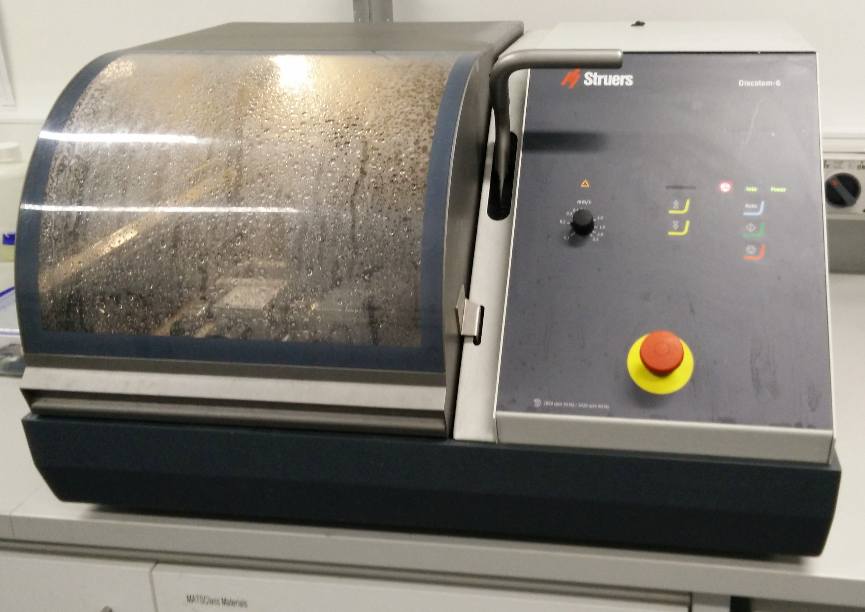

(a)

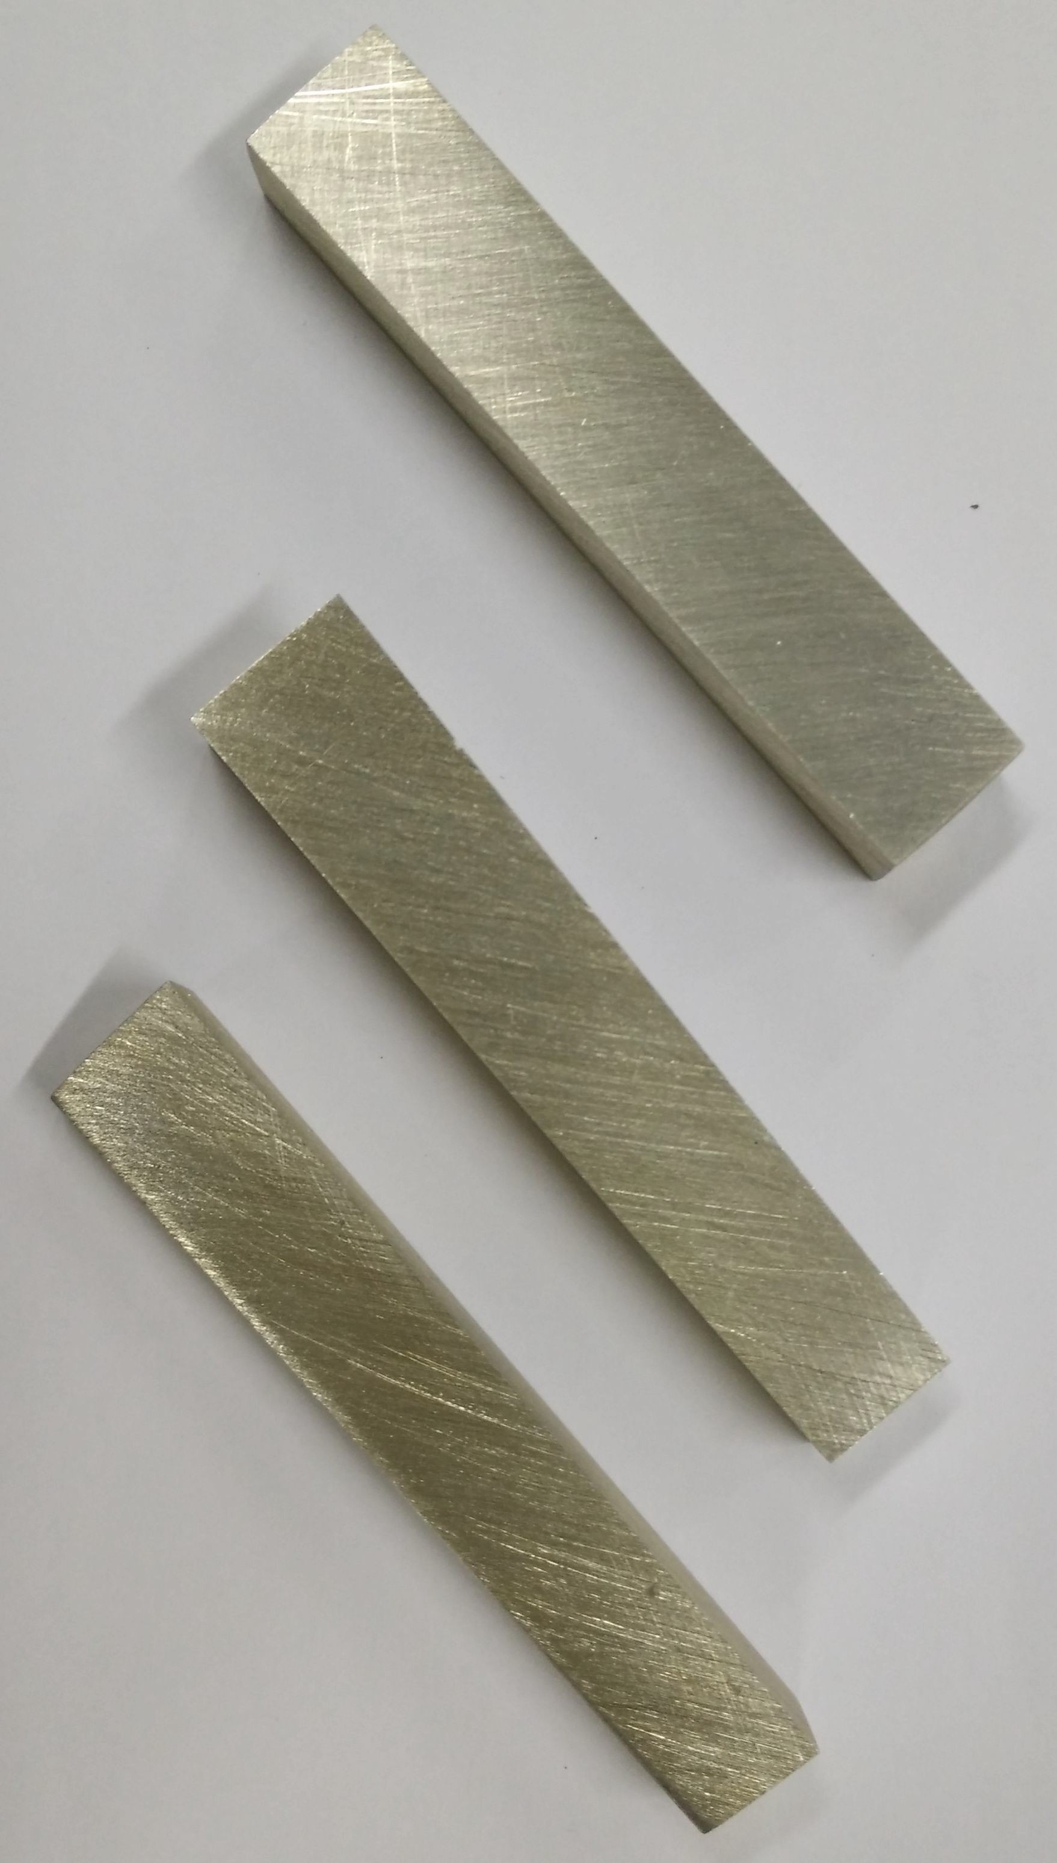

(b)

Figure 1.1: (a) Struers Discotom-6 auto-cutter. (b) Cut and fully deoxided Mg ingot ready for casting.

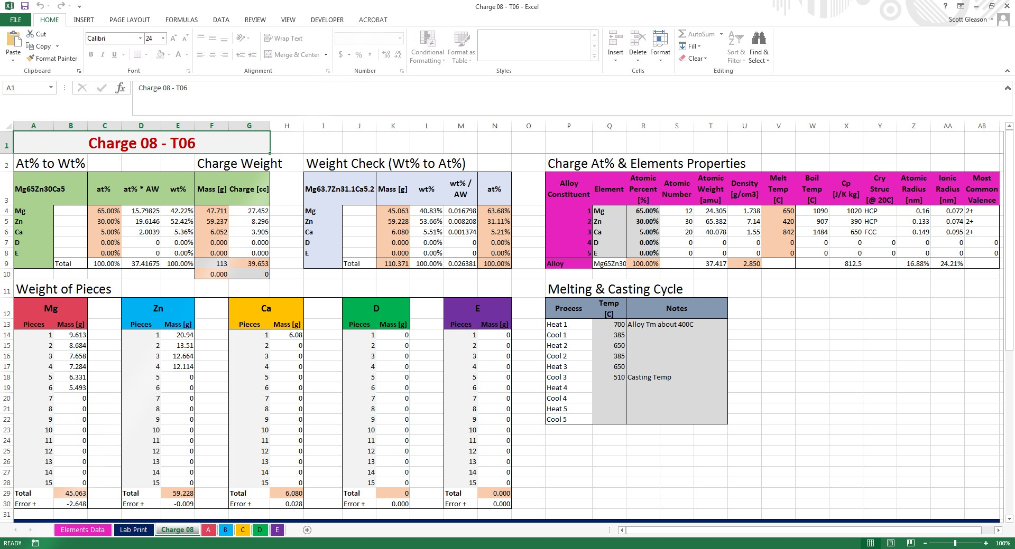

Figure 1.2: Screenshot of the MS Excel workbook developed for auto-calculating master alloy charge weights, checking expected master alloy composition, and taking notes for future refinements.

maximum temperature of 1300*◦*C, heating rate of 500*◦*C/min, and vacuum and dynamic gas melting capability [56]. The dyanmic gas flow rate can be varied from 0 *−* 200 *cm*3 /*min*, and temperature regulated by a K-type thermocouple [56]. The casting capabilities allow for conventional gravity casting, inverted injection casting, vacuum/suction casting, or combination injection/vacuum casting [56].

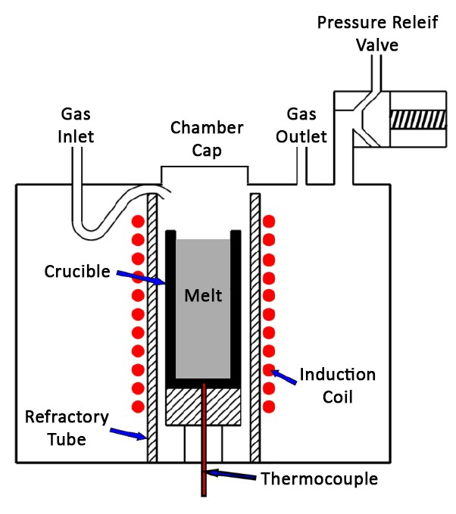

Figure 1.3: Schematic of induction casting melting chamber. Adapted from [56].

**1.1.3 Crucibles**

Boron nitride coated graphite crucibles were used for the melting because the coating is inert with molten Mg. Two sizes are available for the facility, 32*mm* and 34*mm* diameter, by 85*mm* in length, allowing for maximum usable charge volumes of 40 and 60*cc* respectively. The Mg and Zn ingots were placed in the bottom of the crucible with maximum wall contact, with the Ca being added on the top, Figure 1.4b.

**1.1.4 Melt Cycle**

Each prepared crucible was sealed in the induction furnace chamber, evacuated and purged with Ar (99.997 vol.% purity) five times before starting a continues circulating Ar flow through the chamber to prevent oxidation of the melt (Figure 1.3). Alloy homogeneity was ensured by a multi-step heating and cooling cycle to promote thorough mixing of the constituent elements. This heating/cooling cycle between the alloy’s solidus/liquidus region and the liquid state helped ensure a homogeneous alloy melt.

The crucible charge was induction melted at 700*◦*C for a couple minutes and stirred with a tungsten rod. The melt was then partially solidification at 385*◦*C, remelted and stirred at

650*◦*C, partially re-solidification at 385*◦*C, and remelted and stirred again at 650*◦*C. The melt was then cooled to its required casting temperature, held at temperature for approximately

30 seconds, and stirred a final time.

(a) (b)

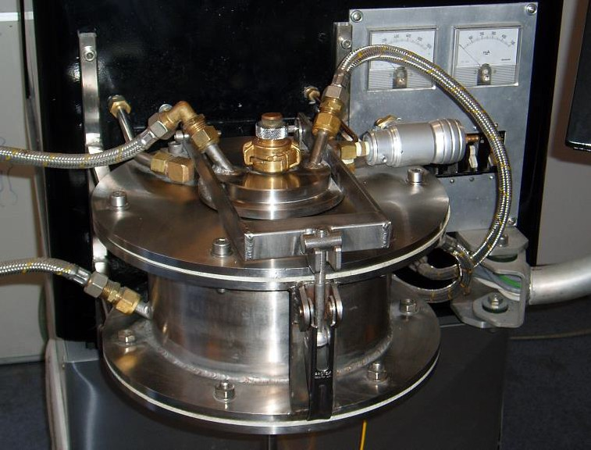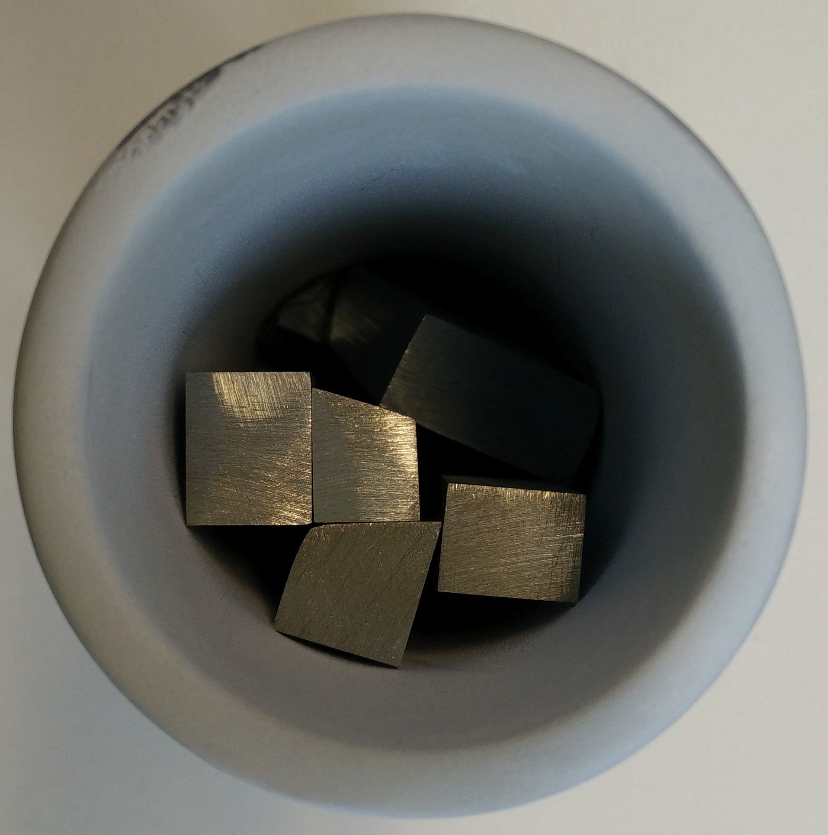

Figure 1.4: (a) In-house ad hoc inducting casting chamber. (b) Boron nitrate coated graphite crucible with Mg and Zn ingot charge. (a) reproduced from [56].

**1.1.5 Gravity Casting**

For naturally cooled gravity castings the casting temperature was 500 *−* 510*◦*C to ensure high molten metal flow and mould filling. The melt crucible was removed from the melt chamber by the incorporated raising bar, and manually poured into a prepared copper mould. The moulds were prepared by cleaning with lint free paper, polishing with Brasso ©, and wiping clean again with the paper.

**1.1.6 Injection Casting**

For injection castings the casting temperature was 450*◦*C to ensure a stable molten metal flow front into the mould. This inverted injection required a silica glass tube of inner diameter 4*mm* be inserted into the melting chamber to act as a flow path between the crucible and the mould. An Ar pressure surge was then applied to the chamber to drive the molten metal up the tube and into the mould. The moulds were prepared by cleaning with lint free paper, polishing with Brasso ©, and wiping clean again with the paper.

**1.2 Bulk Sample Manufacture**

Bulk Mg65Zn30Ca5 samples were produced for comparison to film samples. These were produced by gravity casting and injection casting.

**1.2.1 Gravity Casting**

Gravity cast bulk samples were prepared as per the method detailed in Section 1.1.5. A wedge mould was used to produce bulk metallic glass (BMG) samples for testing. This wedge mould was 100*mm* long, 40*mm* wide, with a maximum thickness of 10*mm*, giving a volume of 20*cc*. Only samples from the tip of the wedge, where the alloy was glassy, were used for experimentation.

**1.2.2 Injection Casting**

Injection cast bulk samples were prepared as per the method detailed in Section 1.1.6. Two different moulds were used, one for rods and one for plates. The rod mould produced samples of nominal 2.5*mm* diameter. The plate mould produced two plates of nominal

1.2*mm* thickness stemming off a central rod spine of 4*mm* diameter.

**1.2.3 Sample Cutting**

The gravity cast wedge moulds could be sheared to sample size with generic pliers.

The injection cast 2.5*mm* diameter rods were sectioned on a low speed saw (Isomet Low Speed Saw, Buehler, USA) with a diamond blade (4” *X* 0.012” *X* 1/2”, Leco, USA) at a control speed of 5 to produce samples of nominal 1*mm* thickness.

The injection cast 1.2*mm* plates were separated from the central rod spine with a wire saw (STX-201 Precision Wire Saw, MTI Corporation, USA). The plates were then sectioned to fit within a 14mm diameter footprint on the low speed saw (same conditions as above).

**1.3 Semi-Crystalline Target Manufacture**

The production of metallic films by physical vapour deposition (PVD) requires targets be manufactured from appropriate master alloy to achieve the desired film stoichiometry. The first method used to manufacture these targets was for semi-crystalline targets.

**1.3.1 Gravity Casting**

Gravity cast semi-crystalline targets were prepared as per the method detailed in Section

1.1.5. For casting these semi-crystalline targets a flat plate mould was used. The casting cavity of this mould was 100*x*50*mm* with spacers allowing for thicknesses ranging from

2*mm* to several *mm*, with 4*mm* plate proving the most practical (Figure 1.5). The 4*mm* plate variation has a volume of approximately 20*cc* with the riser holding an additional 15.5*cc*. The mould was prepared by cleaning with lint free paper, polishing with Brasso ©, and

wiping clean again with the paper.

(a) (b)

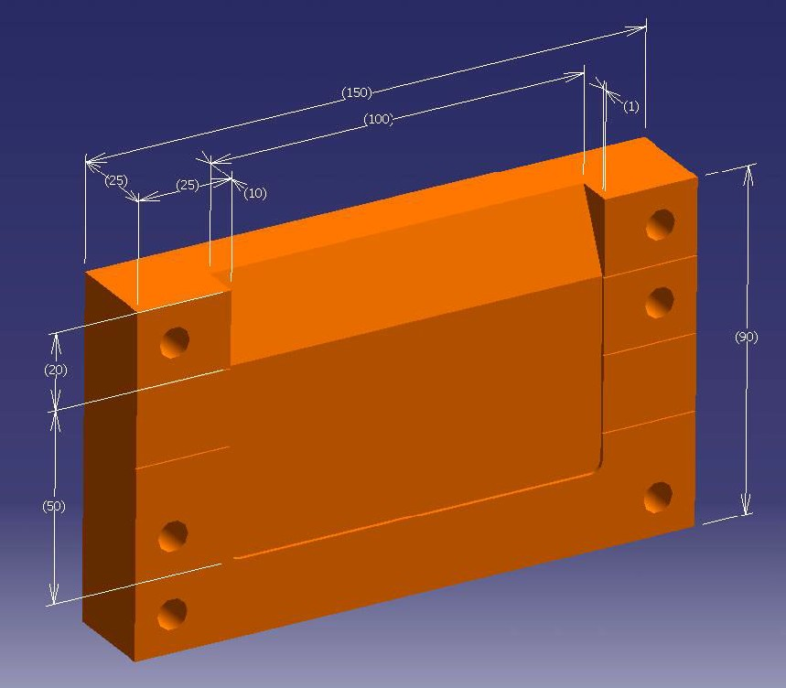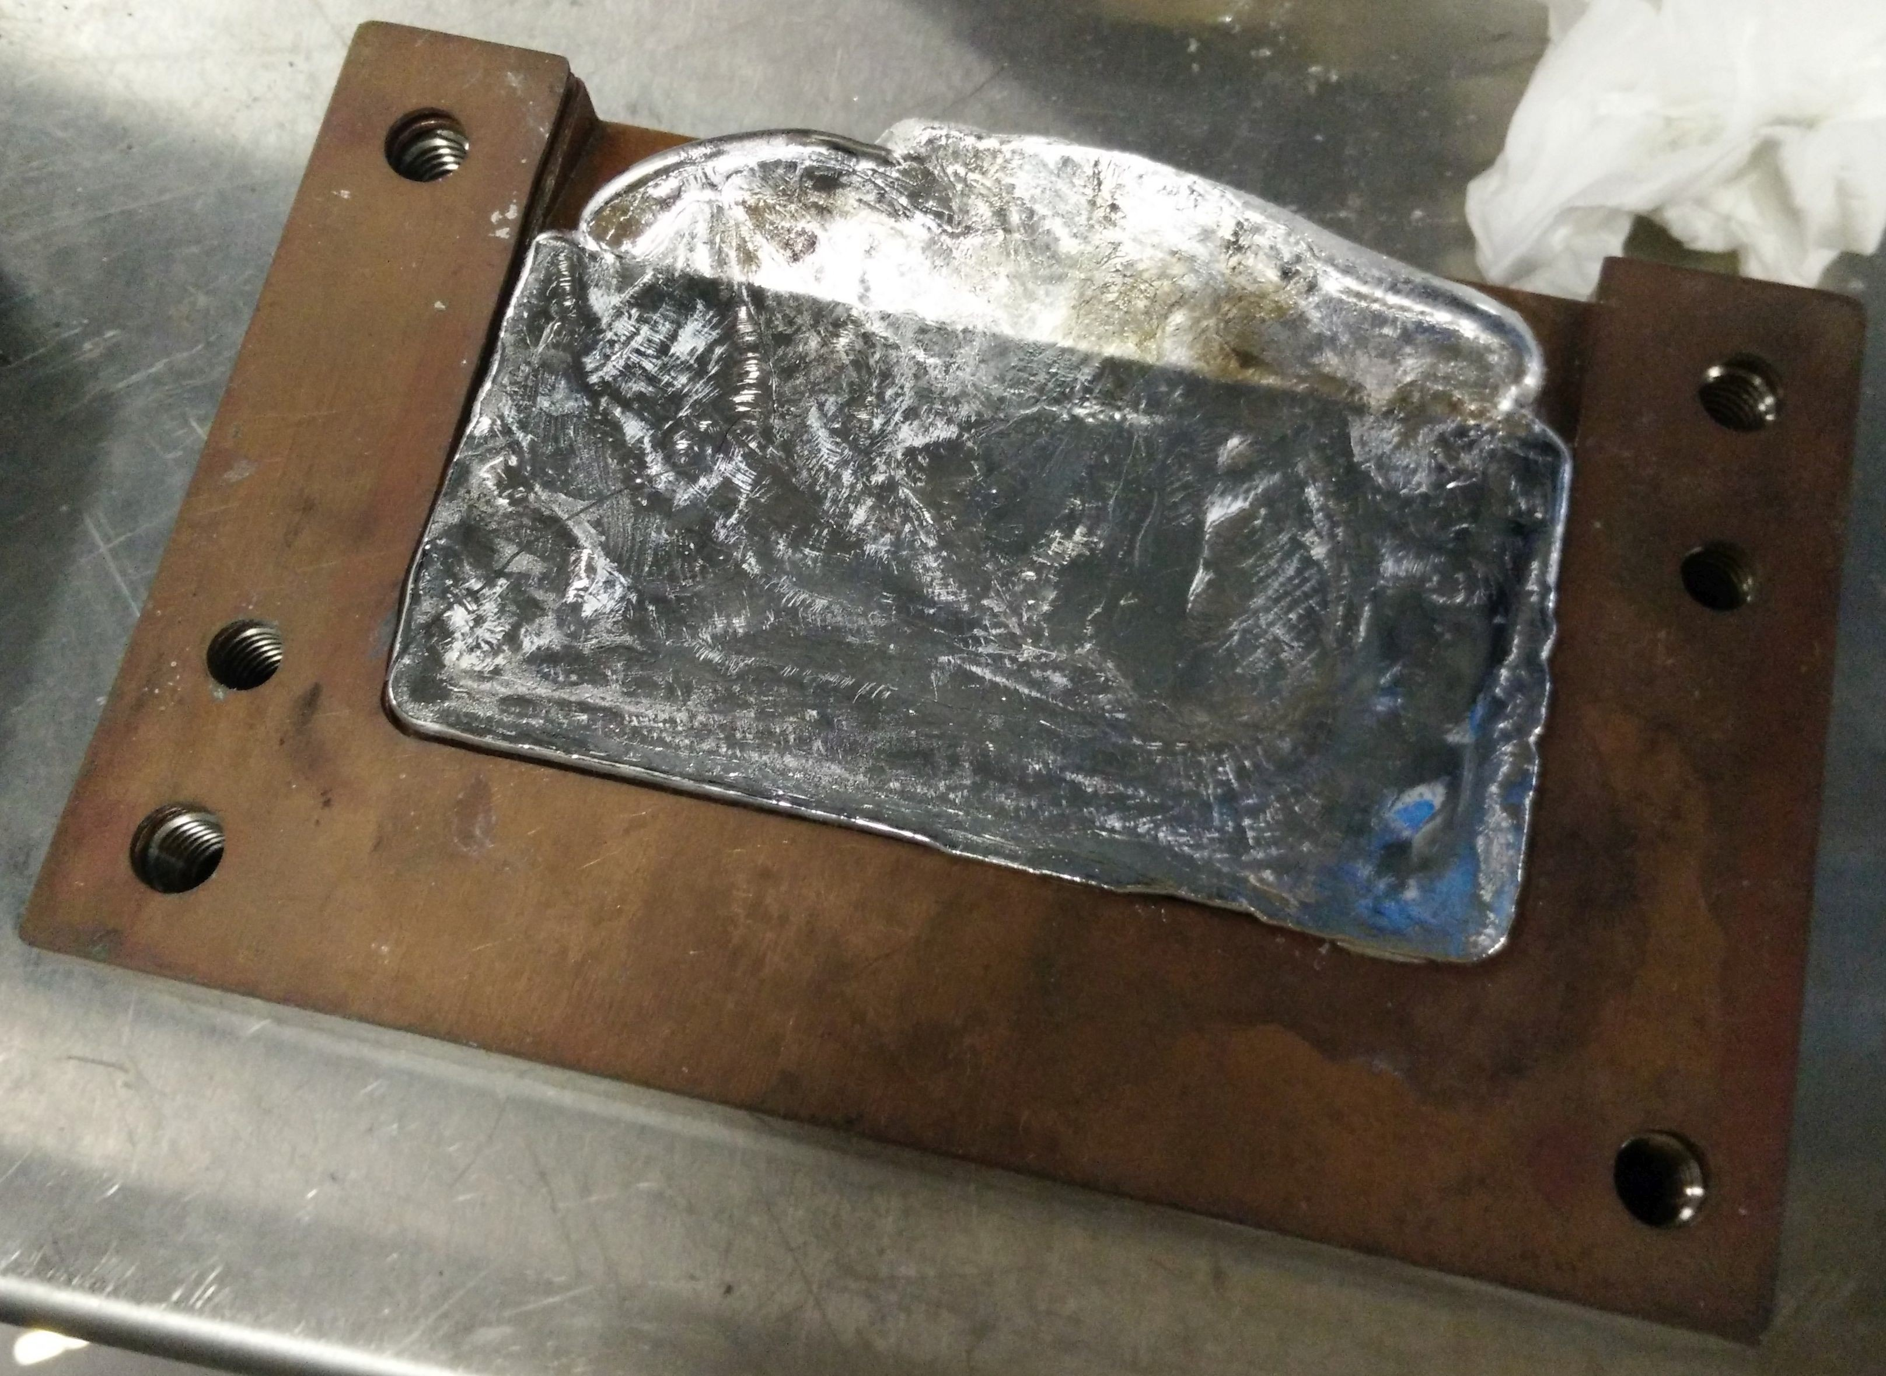

Figure 1.5: (a) 3D schematic of copper plate mould with dimentions in *mm*. (b) Cast

Mg65Zn30Ca5 master alloy plate within mould. (a) reproduced from [56].

**1.3.2 Riser Removal**

Once master alloy plate was cast the riser was removed. The plate was mounted in a polymer grip vice and the riser carefully cut off with a 24 or 32 TPI hacksaw. Paper was placed under the vice grips to capture the metallic saw dust for later analysis (Figure

1.7a).

**1.3.3 Target Extraction**

The target was extracted from the plate by a notched 32*mm* diameter diamond holesaw (Suttontools, Australia) on a drill press (Hercus Sales, Australia) at 360 RPM with a bore rate of approximately 15*mm*/*hr*. The plate was mounted in a polymer grip horizontal vice on top of cut plywood for dampening, and placed in a drip tray. A constant stream of lubricating distilled water was supplied by a standard spray bottle (Figures 1.7c and 1.7d).

**1.3.4 Target Rounding**

The target was then shaped to a nominal 1*in* (25.2 *−* 25.4*mm*) diameter disk by removal of excess circumferential material. Large sections were removed by hacksaw as outlined in Section 1.3.2, with finer shaping accomplished by linishing operations. Target roundness was checked throughout by comparing with a 2 Euro coin or washer template, 25.75*mm* and nominal 25.4*mm* diameter respectively. Final nominal target diameter was confirmed by vernier caliper measurement (Figure 1.7b).

**1.3.5 Target Polishing**

The target was progressively manually polished with light pressure on glass plate in a figure eight pattern with flowing lubricating water. The target was polished on both sides and rotated through small angles every couple seconds to ensure a consistent flat surface. The grit progression was 320, 800, 1200, and 4000 with target washing between all stages. After

800 and higher grit stages the target was ultrasound cleaned for 1 minute in soap and water. Polishing wheels were not used because they produce a less consistent flat surface and targets require high surface tolerance to fire within the sputtering gun. Target flatness was checked by micrometre, with nominal variation between the two opposing surfaces being less than 1% the target diameter, about 0.254*mm*.

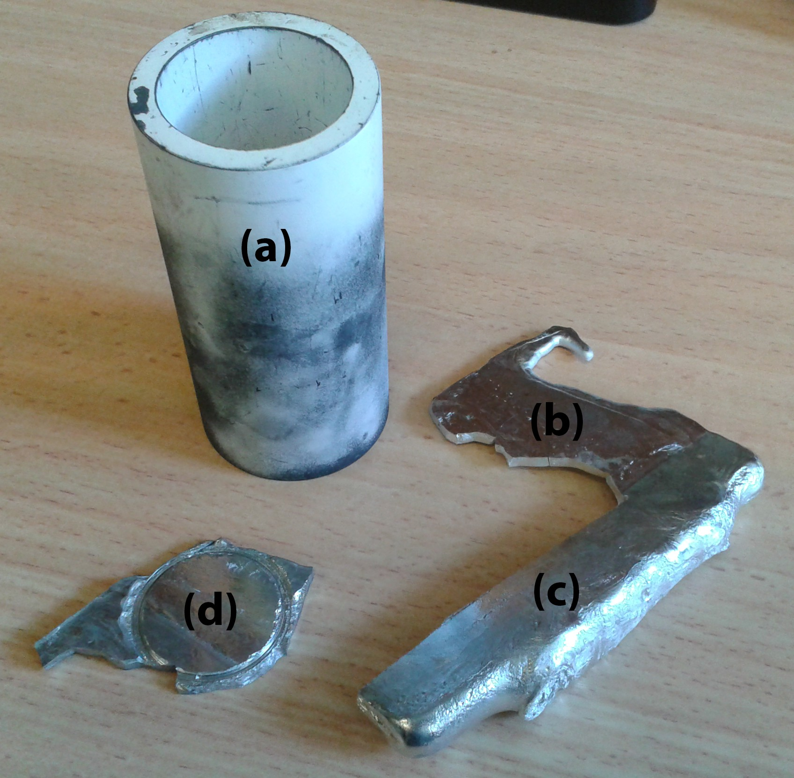

Figure 1.6: (a) Boron nitrate coated graphite crucible for induction furnace melting of alloys, (b) Cracked Mg65Zn30Ca5 master alloy plate, (c) Riser cut free from main casting, and (d) Drilled and partly shaped target.

(a) (b)

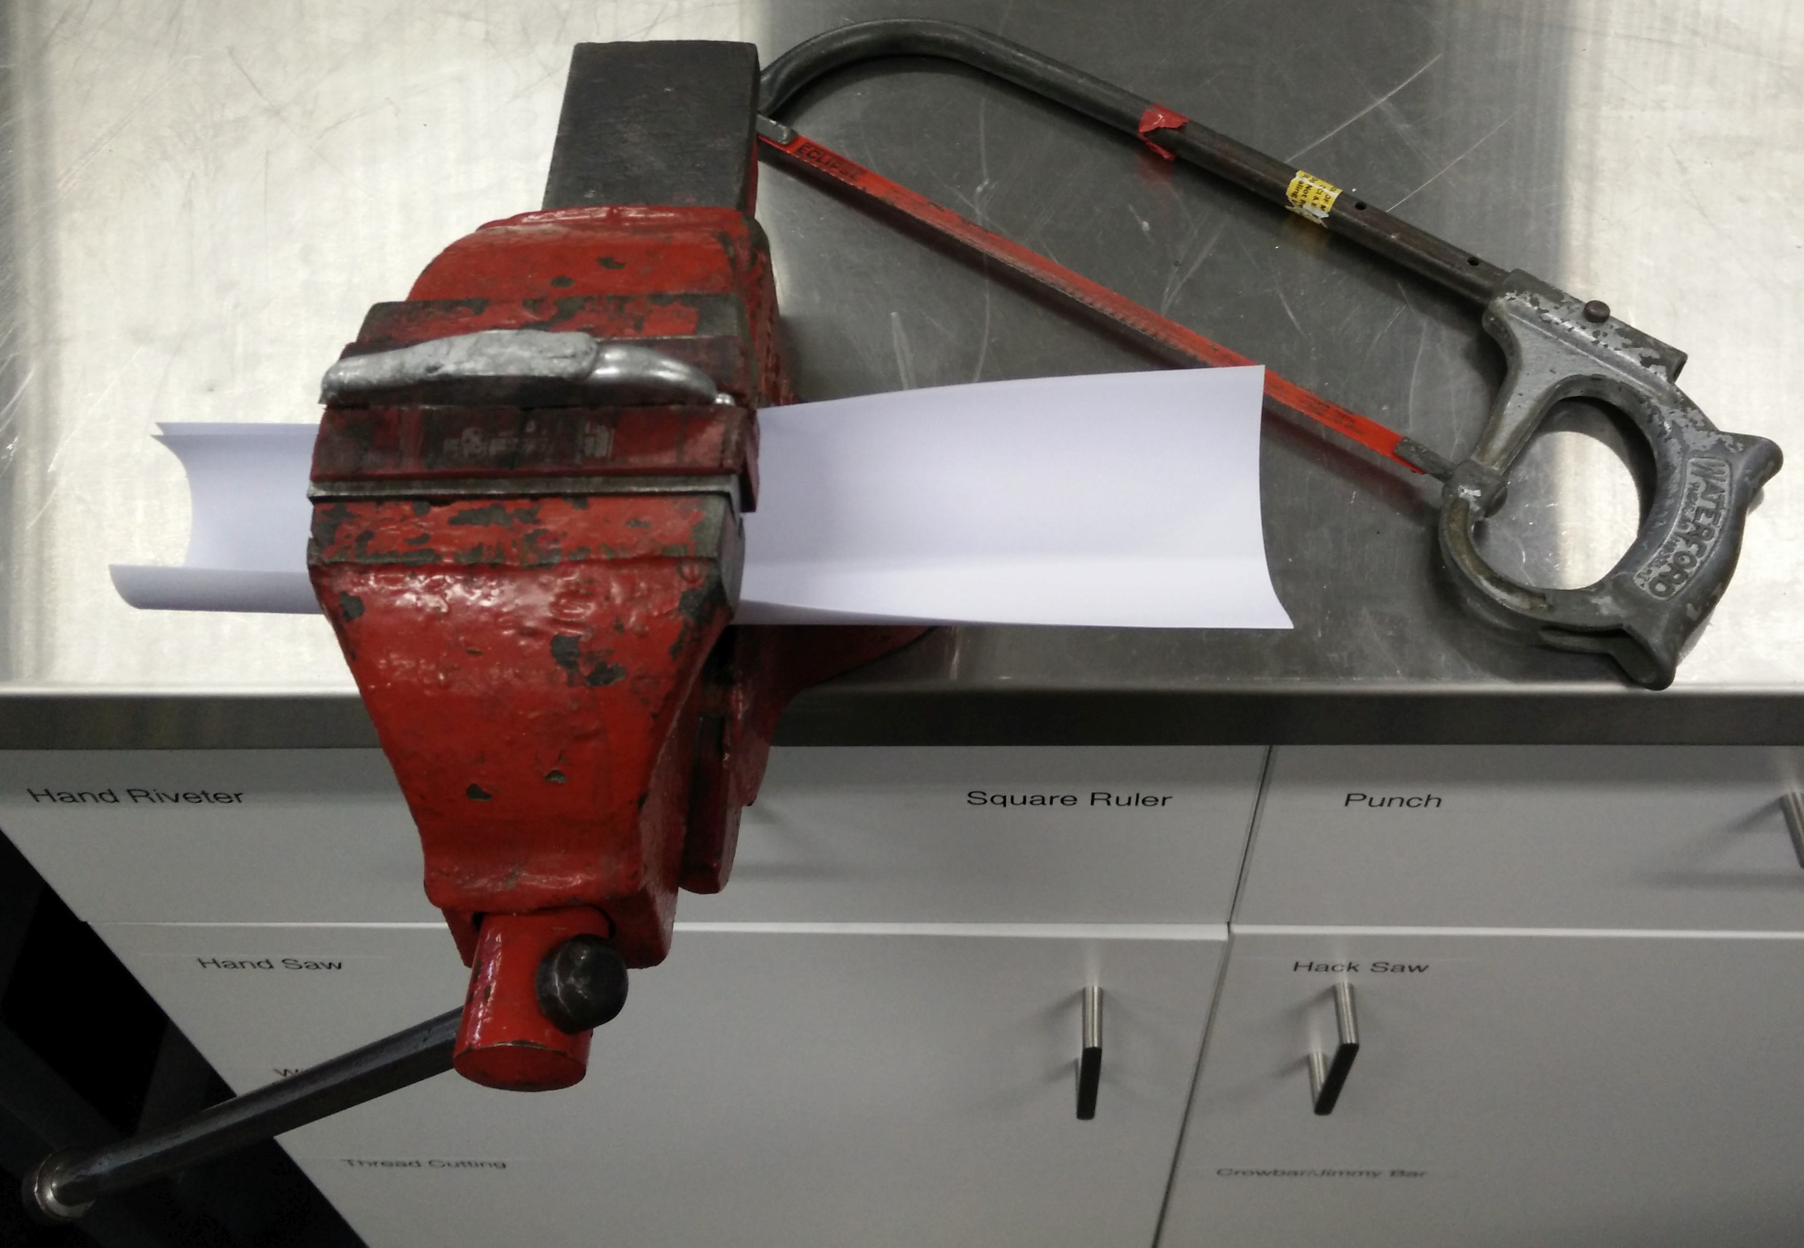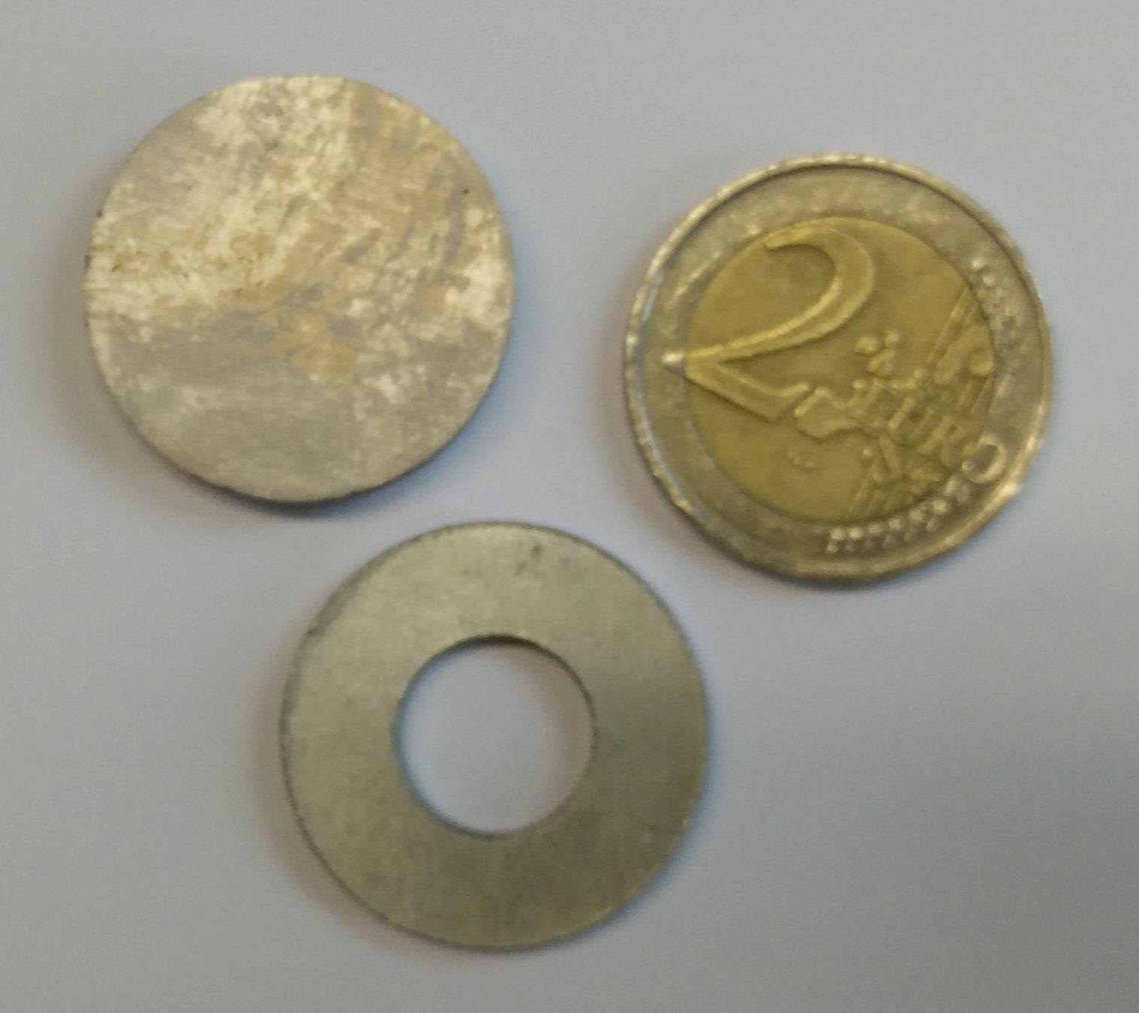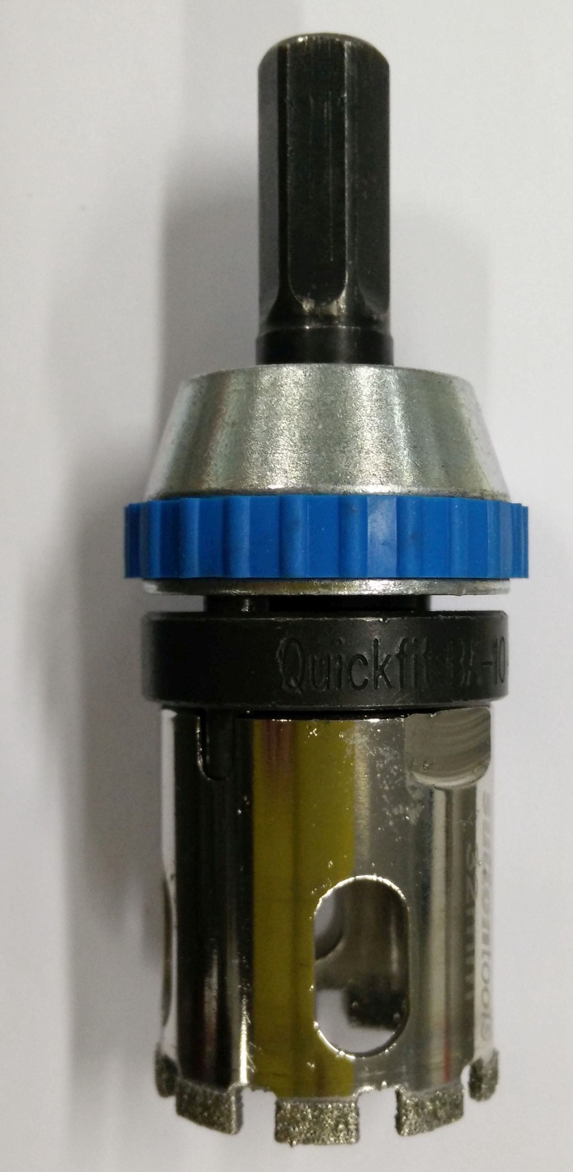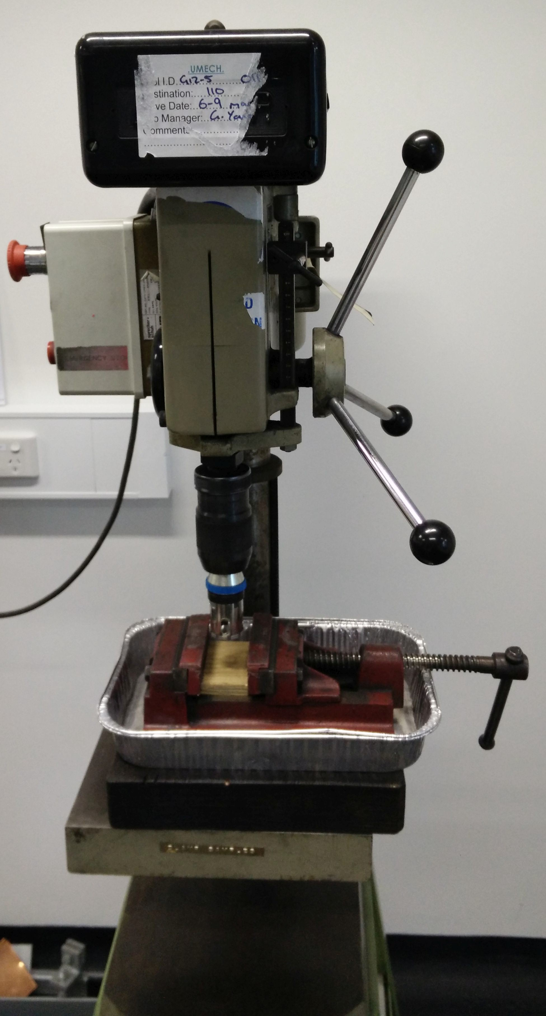

(c) (d)

Figure 1.7: (a) Polymer grip vice clamping plate below riser with 32 TPI hacksaw. (b) Fully shaped, unpolished target with 2 Euro coin and washer template. (c) Notched 32*mm* diameter diamond holesaw. (d) Drill press, holesaw, horizontial vice with polymer grips, plywood damper, and drip tray for target extraction.

**1.4 Crystalline Target Manufacture**

Fully crystalline targets were later manufactured as they could be produced more quickly and found to provided similar deposition results to semi-crystalline targets.

**1.4.1 Gravity Casting**

Gravity cast semi-crystalline targets were prepared as per the method detailed in Section

1.1.5. The copper cylinder mould cavity diameter was 25.6*mm*, with a depth of 60*mm*, and no riser allowing for a casting volume of approximately 30*cc*. The mould was prepared by cleaning with lint free paper, polishing with Brasso ©, and wiping clean again with the paper.

**1.4.2 Sectioning of Targets**

Once cast the top and bottom quarter of the casting was removed on an auto-cutter (Accutom-50, Struers, Denmark) fitted with a diamond blade (4” *X* 0.012” *X* 1/2”, Leco, USA) at a feed rate of no more than 0.02*mm*/*s* at 2000 RPM with medium force. This removed any inconsistencies / non-homogeneous material resulting from the quick initial cooling at the base of the mould, and the final feeding of the last liquid melt. The remaining, consistent casting was then sectioned into nominally 3.85*mm* thick targets.

(a) (b)

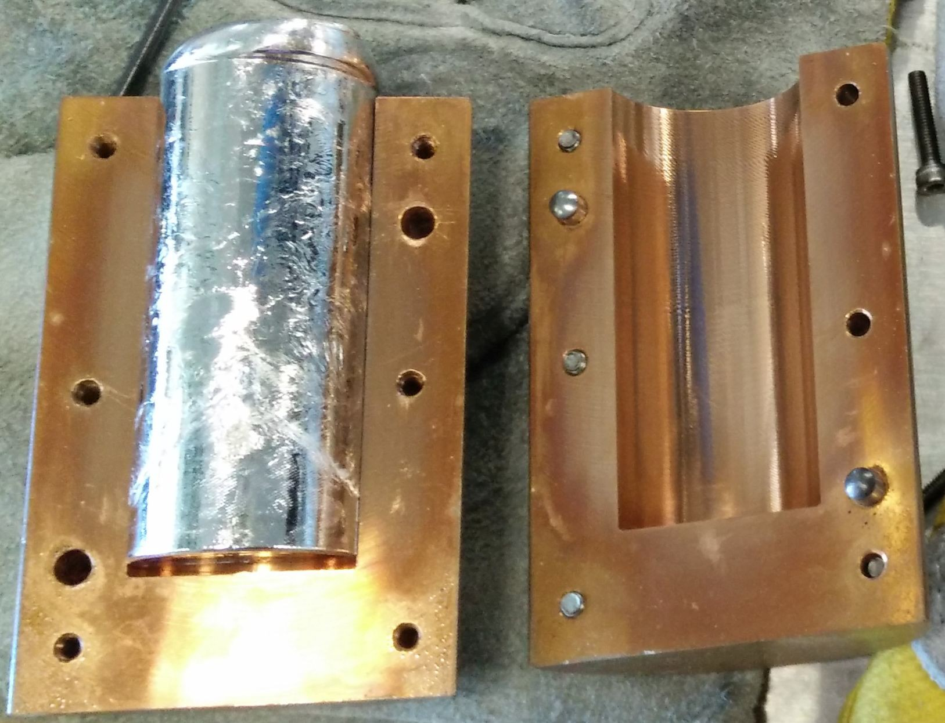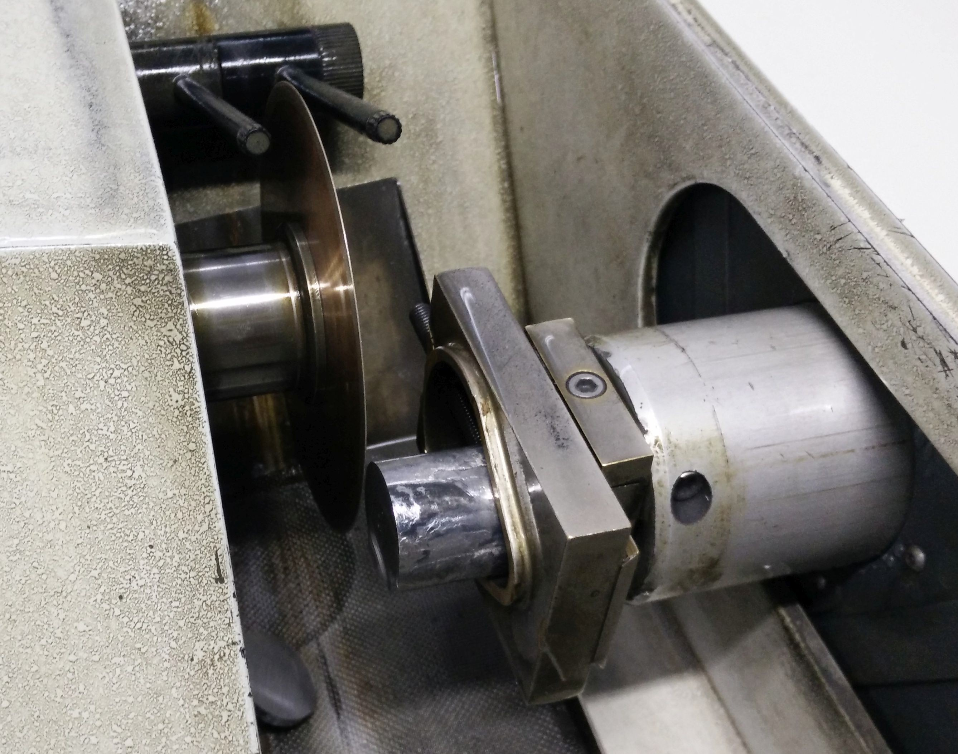

Figure 1.8: (a) Crystalline target cast in a copper cylinder mould. (b) Cutting crystalline target on struers Accutom-50.

**1.4.3 Target Rounding**

Sectioned targets were slightly oversized and quickly shaped to a nominal 1*in* (25.2 *−*

25.4*mm*) diameter disk by linishing operations and confirmed by vernier caliper measurement.

**1.4.4 Target Polishing**

The target were progressively manually polished as detailed in Section 1.3.5.

**1.5 DC Magnetron Sputtering**

Film Mg65Zn30Ca5 samples were produced for comparison to bulk samples. These were produced by DC magnetron sputtering.

**1.5.1 DC Magnetron Sputtering**

The films were deposited by an in-house ad hoc DC magnetron sputtering facility (Figure

1.9). This facility has a maximum power of 50*W*, with a working gas of ultra-high purity Ar (99.999%). The sputtering gun is water cooled with a nominal target diameter of 25.4*mm* (1*in*). The working distance between target and substrate stage is 8*cm*. The chamber can achieve a base vacuum pressure of at least 10*−*3 Torr, and has adjustable working Ar pressure supplied at a constant flow rate. The chamber has direct access and a large deposition area, allowing for batch processing of multiple substrates simultaneously.

**1.5.2 Deposition of Films**

A target was carefully affixed in the sputtering gun mount to ensure coincident, level contact with the copper holder. The desired substrates were position directly below the target on the sample stage within the chamber, the shield was positioned over the substrates, and the chamber was sealed. The chamber was then fully evacuated to the base pressure limits of the vacuum pump.

For depositions the chamber was backfilled to a working Ar pressure of 1*Pa* with a coincident Ar flow of 3.01 SCCM. The gun was fired at a power of 15*W*, with typical voltage

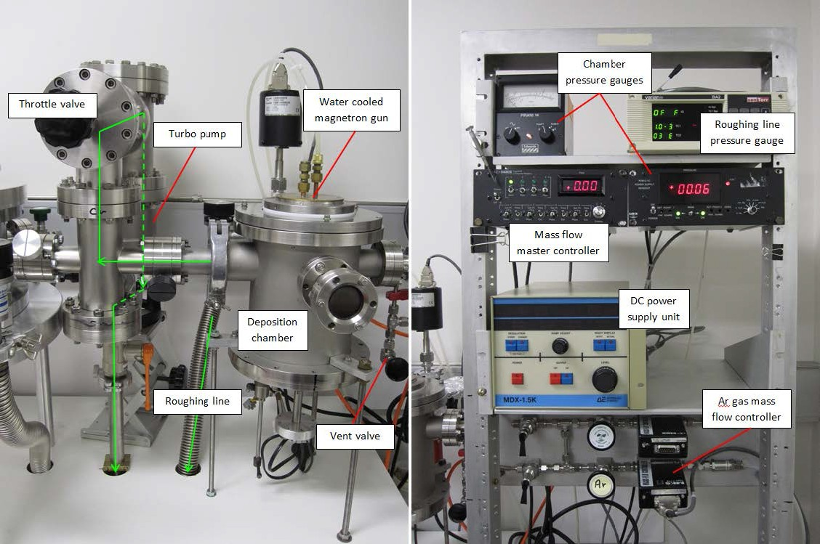

Figure 1.9: In house DC magnetron sputtering facility. Reproduced from [21].

of 285 *−* 325*V*. The substrate stage was nominally at room temperature, uncooled, and its temperature rise monitored with a k-type thermocouple.

To begin a deposition a target was prepared by a pre-sputter to remove contamination and oxides from its surface. For fresh targets this pre-sputter was for 5 minutes, and for used targets it was 1 minute. During this stage the substrates were protect by a shield positioned over the sample area to prevent deposition. The shield was then removed to begin a deposition for 35 minutes unless otherwise noted, see Table 1.1.

Table 1.1: Nominal sputtering parameters.

Deposition Conditions

Power 15*W* Voltage 285 *−* 325*V* Base pressure 1*Pa*

Ar flow rate 3.01 SCCM Substrate temperature 25*◦*C

Pre-sputter (fresh target) 5 minutes Pre-sputter (used target) 1 minute Deposition time 35 minutes

**1.6 Examined Substrates**

The Mg65Zn30Ca5 films were deposited onto three different substrates for examination; Al

DSC lid substrates, silica glass slide substrates, and silicon wafer substrates.

**1.6.1 Al DSC Lid Substrate**

Films were deposited directly onto Al differential scanning calorimetry (DSC) lids (Netzsch, Germany)to use as the main substrate for these works. These substrates were used as they allowed for the collection of reliable DSC data, and could be used to obtain coincident results with other techniques.

**1.6.2 Silica Glass Substrate**

Silicon glass substrates (Corning Inc., USA) were primarily used for film thickness measurements. They could also be used to verify that results were consistent across various substrates by comparing with the DSC lid results. These substrates were cleaned in an ethanol ultrasound bath for at least 1 minute before being used.

**1.6.3 Silicon Wafer Substrate**

Depositions onto un-doped, single side polished (SSP) 500 *±* 10*µm*, (100) silicon wafer (UniversityWafer, USA) was occasionally used for specific X-ray diffraction (XRD) and other experiments. These substrate were used for these specialised experiments as some film properties can to be more easily examined with the minimal substrate influence available from Si compared to other substrates. These substrates were cleaned in an ethanol ultrasound bath for at least 1 minute before being used.

**1.7 Storage**

The Mg65Zn30Ca5 alloy is known to be sensitive to atmospheric conditions, and careful storage is required to mitigate these effects.

**1.7.1 Desiccator**

All samples and targets were stored in individual polymer sample bags before storing in a vacuum glass desiccator (E124-150, ProSciTech, Australia). This desiccator had silica gel beads added below the porcelain base plate to ensure minimal moister within the chamber. The desiccator was sealed by applying a small amount of vacuum grease (Thermo Fisher Scientific, USA) around the flange. To mitigate atmospheric effects the desiccator atmosphere was vacuumed and backfilled with ultra-high purity Ar (99.999%). A purge cycle of 10 *−* 15 fills between a gauge pressure of 0.0*kPa* and *−*67.3*kPa* (*−*20 In-Hg) was used to minimise the residual atmosphere present in the desiccator. The desiccator was protected from accidental breakage by protective netting (Australian Netting and Extrusions, Australia).

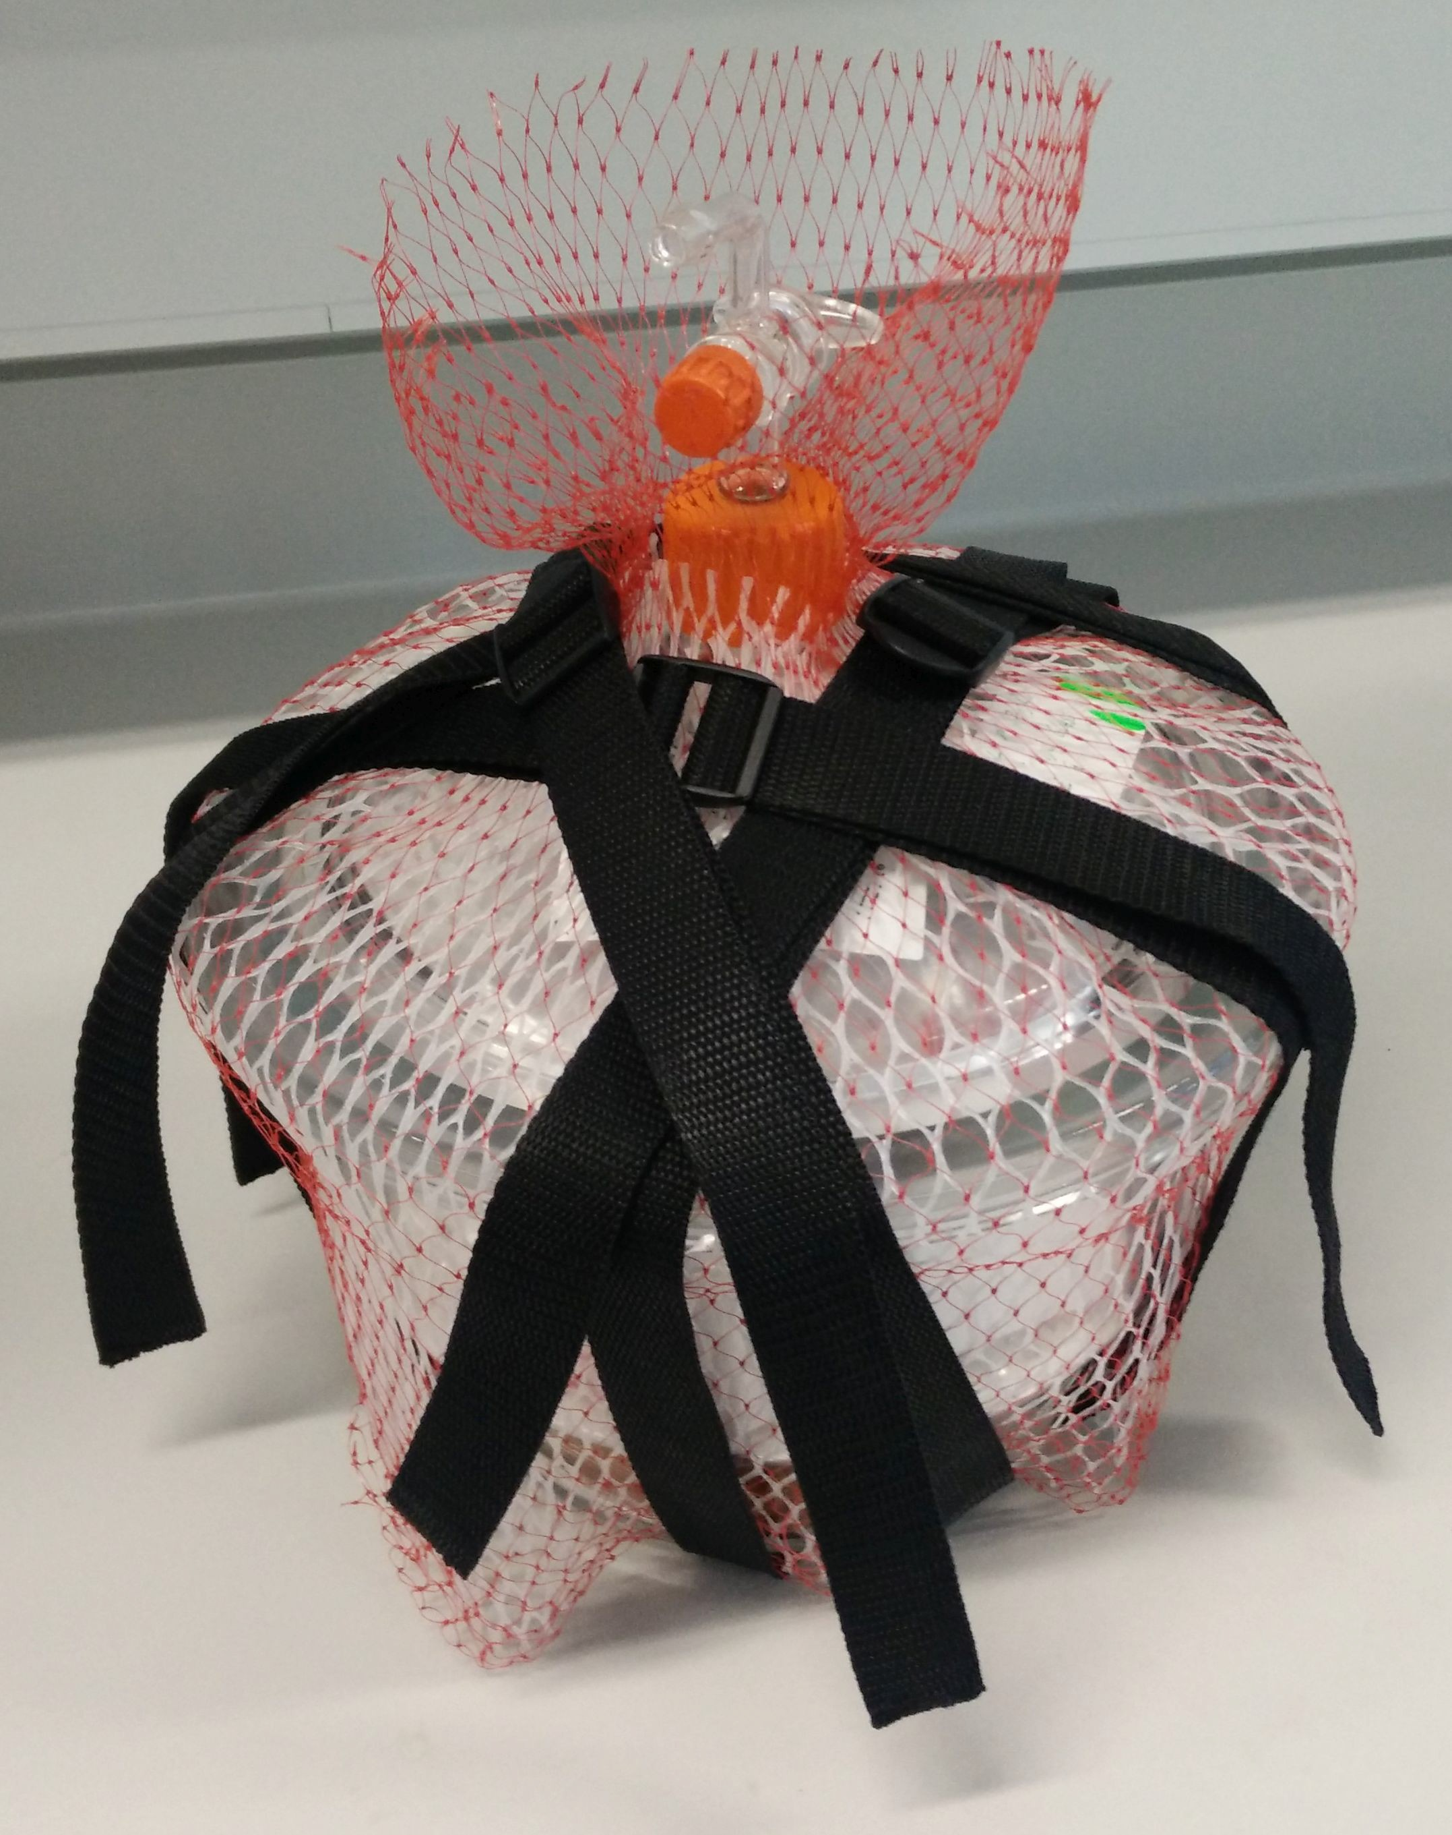

Figure 1.10: Vacuum glass desiccator with protective netting.

**1.8 Characterisation**

Both bulk and film Mg65Zn30Ca5 samples were characterised and analysis with numerous techniques.

**1.8.1 Stylus profiler characterisation**

Nominal film thickness was measure by a stylus profiler (Dektak 2A, Bruker, Germany). A glass slide was placed under the Al DSC lid substrates within the sputtering chamber, allowing the substrates to act as a mask. Profile measurements were taken by measuring the height difference between the bare glass and the film coated glass. This film thickness was used to estimate the sputter deposition rate.

**1.8.2 SEM characterisation**

Alloy surface features were examined with scanning electron microscopy (SEM) (S3400-N, Hitachi, Japan; Nova NanoSEM 230/450, FEI, The Netherlands). Imaging was done with an accelerating voltage of 5*keV*, a probe current of 50*µ A*, spot size 3, and working distance of

5*mm*.

**1.8.3 EDS characterisation**

Alloy composition and homogeneity were confirmed by SEM-EDS (S3400-N, Hitachi, Japan; Nova NanoSEM 230/450, FEI, The Netherlands). Hyper-maps were collected with an accelerating voltage of 15 *−* 20*keV*, a probe current of 50*µ A*, spot size 4.2, counts of 5000*c ps* or better, dead time less than 20%, working distance 5*mm* (Nova NanoSEM) or 10*mm* (S3400-N), and collection time of 5 *−* 15 minutes.

**1.8.4 DSC characterisation**

Isochronic DSC (204 F1 Phoenix, Netzsch, Germany) was carried out in Al crucibles under a protective Ar atmosphere (99.997 vol.% purity). Scans were performed at heating rates (*β*s) of 5 to 100*K*/*min*.

Isothermal relaxation DSC was preformed by heating samples at 20*K*/*min* to the desired annealing temperature, holding for the desired time, and Ar quenching to room temperature.

For annealed XRD the samples were heat treated in the DSC by heating to the desired temperature at 20*K*/*min* followed by Ar quenching to room temperature.

Isothermal crystallisation DSC was preformed by heating samples at a variable rate to ensure they reach the desired annealing temperature with the minimal practicable

temperature and sensor fluctuations. The samples were then held for the desired time, and Ar quenched to room temperature. This level of control was required for isothermal crystallisation DSC due to the low data resolution of these experiments.

Table 1.2: Example isothermal crystallisation DSC variable heating rate profile to 100*◦*C. An isothermal experiment at a higher temperature would add the difference to each step, except for the starting temperature (i.e. for 105*◦*C, add 5*◦*C to all steps except for 25*◦*C).

Temperature Heating Rate Step Time Total Time

*◦*C K/min sec sec

|  |  |  |  |
| --- | --- | --- | --- |
| 25 | - | - | 0 |
| 45 | 100 | 12.0 | 12.0 |
| 60 | 75 | 12.0 | 24.0 |
| 70 | 50 | 12.0 | 36.0 |
| 80 | 33 | 18.2 | 54.2 |
| 90 | 20 | 30.0 | 84.2 |
| 94 | 11 | 21.8 | 106.0 |
| 97 | 7 | 25.7 | 131.7 |
| 98.5 | 5 | 18.0 | 149.7 |
| 100 | 2.5 | 36.0 | 185.7 |

**1.8.5 XRD characterisation**

Annealing XRD (Empyrean, PANalytical, The Netherlands, Cu *Kα* X-ray source, *λ* = 1.541Å) was performed on heat treated bulk rods, and films at room temperature. The operating parameters were: generator voltage 45*kV*, tube current 40*m A*, scan step size 0.0262606, and time per step of 397.29.

Dynamic XRD (D8, Bruker, Germany, Cu *Kα* X-ray source, *λ* = 1.541Å) was performed on as manufactured bulk injection plates, and films by raising temperature at a rate of 20*K*/*min* and performing scans *in situ*. The first scan was performed at 35*◦*C, then 75*◦*C, after which temperature was raised in 5*◦*C increments until reaching a finish temperature at 185*◦*C. The 2*θ* scans from 31 *−* 60*◦* were completed within 1092*sec* (18*min*, 12*sec*) to minimise the effects of recrystallisation at temperature during the experiment. The operating parameters were: generator voltage 45*kV*, tube current 100*m A*, scan step size 0.02, and time per step of

134.4.

**1.8.6 Nano-indentation characterisation**

Nano-indentation (TriboIndenter TI900, Hysitron, USA) was preformed on both the bulk, and film Mg65Zn30Ca5 to comparable the hardness and reduced modulus (Er). The

nano-indentator was fitted with a standard Berkovich tip with total included angle of

142.35*◦* and half-angle 65.35*◦*. The nano-indentator was calibrated aginsted a fused quartz reference sample before each use.

The samples were prepared by mounting onto stainless steel disks (approximate diameter

28*mm* , height 10*mm*) with super glue. This was done to ensure a smooth surface and consistent compliance between all samples. The nano-indentation measurements were performed with a load of 1000*µN* applied with a loading period of: 10 second ramp to load, 5 second hold at load, and 10 second ramp down to no-load. Each examined location had 9 independent indents performed within a 3*x*3 grid with 10*µm* spacing between each measurement. Each sample had 2 to 4 locations examined to ensure each sample was statically significant.

**1.8.7 AFM characterisation**

Sample surface textures were examined with atomic force microscopy (AFM) (Dimension ICON, Bruker, Germany) with a ScanAsyst-Air probe (Bruker, Germany). The scan rate was 0.814*Hz*, amplitude setpoint 205.23*mV*, and drive amplitude 729.06*mV*. Scans were preformed over a cross sectional area of 2*x*2 or 5*x*5*µm*. The samples were placed directly onto the examination stage and held in place by a vacuum.

**1.8.8 FIB characterisation**

A focused ion beam (FIB) (XP200, FEI, The Netherlands) was used to cut cross sections into film surfaces. Samples were mounted to the testing stage with silver paint and sputter coated with a thin layer of gold. The examined areas of samples were coated with platinum before milling with gallium ions. Imaging on the FIB was done with an accelerating voltage of 30*keV*, and probe current of 12*p A*.

**Chapter 2**

**BIBLIOGRAPHY**

[1] A. L. Greer, Y. Q. Cheng, and E. Ma. Shear bands in metallic glasses. *Materials Science and Engineering: R: Reports*, 74(4):71–132, 2013.

[2] MD Ediger, CA Angell, and Sidney R Nagel. Supercooled liquids and glasses. *The journal of physical chemistry*, 100(31):13200–13212, 1996.

[3] Kikujiro Ishii and Hideyuki Nakayama. Structural relaxation of vapor-deposited molecular glasses and supercooled liquids. *Physical Chemistry Chemical Physics*,

16(24):12073–12092, 2014.

[4] Daisman PB Aji, Akihiko Hirata, Fan Zhu, Liu Pan, K Madhav Reddy, Shuangxi Song, Yanhui Liu, Takeshi Fujita, Shinji Kohara, and Mingwei Chen. Ultrastrong and ultrastable metallic glass. *arXiv preprint arXiv:1306.1575*, 2013.

[5] W Klement, RH Willens, and POL Duwez. Non-crystalline structure in solidified gold-silicon alloys. *Nature*, 187:869–870, 1960.

[6] Akihisa Inoue. Stabilization of metallic supercooled liquid and bulk amorphous alloys.

*Acta Materialia*, 48(1):279–306, 2000.

[7] Morgana Martin Trexler and Naresh N. Thadhani. Mechanical properties of bulk metallic glasses. *Progress in Materials Science*, 55(8):759–839, 2010.

[8] David Turnbull. Under what conditions can a glass be formed? *Contemporary Physics*,

10(5):473–488, 1969.

[9] Jan Schroers. Processing of bulk metallic glass. *Advanced Materials*, 22(14):1566–1597,

2010.

[10] Jinn P. Chu, J. E. Greene, Jason S. C. Jang, J. C. Huang, Yu-Lin Shen, Peter K.

Liaw, Yoshihiko Yokoyama, Akihisa Inoue, and T. G. Nieh. Bendable bulk metallic

glass: Effects of a thin, adhesive, strong, and ductile coating. *Acta Materialia*,

60(6-7):3226–3238, 2012.

[11] F. X. Liu, F. Q. Yang, Y. F. Gao, W. H. Jiang, Y. F. Guan, P. D. Rack, O. Sergic, and P. K. Liaw. Micro-scratch study of a magnetron-sputtered Zr-based metallic-glass film. *Surface and Coatings Technology*, 203(22):3480–3484, 2009.

[12] Braham Prakash. Abrasive wear behaviour of Fe, Co and Ni based metallic glasses.

*Wear*, 258(1-4):217–224, 2005.

[13] C. L. Chiang, J. P. Chu, F. X. Liu, P. K. Liaw, and R. A. Buchanan. A 200nm thick glass-forming metallic film for fatigue-property enhancements. *Applied Physics Letters*,

88(13):–, 2006.

[14] J. P. Chu, C. M. Lee, R. T. Huang, and P. K. Liaw. Zr-based glass-forming film for fatigue-property improvements of 316L stainless steel: Annealing effects. *Surface and Coatings Technology*, 205(16):4030–4034, 2011.

[15] C. W. Chu, Jason S. C. Jang, S. M. Chiu, and J. P. Chu. Study of the characteristics and corrosion behavior for the Zr-based metallic glass thin film fabricated by pulse magnetron sputtering process. *Thin Solid Films*, 517(17):4930–4933, 2009.

[16] P. H. Tsai, Y. Z. Lin, J. B. Li, S. R. Jian, J. S. C. Jang, C. Li, J. P. Chu, and J. C. Huang.

Sharpness improvement of surgical blade by means of ZrCuAlAgSi metallic glass and metallic glass thin film coating. *Intermetallics*, 31(0):127–131, 2012.

[17] Jinn P. Chu, J. S. C. Jang, J. C. Huang, H. S. Chou, Y. Yang, J. C. Ye, Y. C. Wang, J. W.

Lee, F. X. Liu, P. K. Liaw, Y. C. Chen, C. M. Lee, C. L. Li, and Cut Rullyani. Thin film metallic glasses: Unique properties and potential applications. *Thin Solid Films*,

520(16):5097–5122, 2012.

[18] Hans-Ulrich Krebs and Olaf Bremert. Pulsed laser deposition of thin metallic alloys.

*Applied Physics Letters*, 62(19):2341–2343, 1993.

[19] D Dijkkamp, T Venkatesan, XD Wu, SA Shaheen, N Jisrawi, YH Min-Lee, WL McLean, and M Croft. Preparation of Y-Ba-Cu oxide superconductor thin films using pulsed laser evaporation from high Tc bulk material. *Applied Physics Letters*, 51(8):619–621,

1987.

[20] J Heitz, XZ Wang, P Schwab, D Bäuerle, and L Schultz. KrF laser-induced ablation and patterning of Y-Ba-Cu-O films. *Journal of Applied Physics*, 68(5):2512–2514, 1990.

[21] Jake Diablo Cao. Processing and properties of biocompatible metallic glasses, 2013.

[22] T.E. Brown, T.L. Brown, H.E.H. LeMay, B.E. Bursten, C. Murphy, and P. Woodward.

*Chemistry: The Central Science*. Pearson Education, 2014.

[23] Y. H. Liu, T. Fujita, A. Hirata, S. Li, H. W. Liu, W. Zhang, A. Inoue, and M. W.

Chen. Deposition of multicomponent metallic glass films by single-target magnetron sputtering. *Intermetallics*, 21(1):105–114, 2012.

[24] Katsuyoshi Kondoh, Kenshi Kawabata, Tadashi Serikawa, and Hisamichi Kimura.

Structural characteristics and crystallization of metallic glass sputtered films by using

Zr system target. *Advances in Materials Science and Engineering*, 2008, 2008.

[25] Zbigniew W. Kowalski. Ion sputtering and its application to biomaterials. *Journal of*

*Materials Science*, 18(9):2531–2543, 1983.

[26] Y. P. Deng, Y. F. Guan, J. D. Fowlkes, S. Q. Wen, F. X. Liu, G. M. Pharr, P. K. Liaw, C. T.

Liu, and P. D. Rack. A combinatorial thin film sputtering approach for synthesizing and characterizing ternary ZrCuAl metallic glasses. *Intermetallics*, 15(9):1208–1216, 2007.

[27] Jing Qin, Xu Yong, Zhang Xin-Yu, Li Gong, Li Li-Xin, Xu Zhe, Ma Ming-Zhen, and Liu Ri-Ping. Zr-Cu amorphous films prepared by magnetron co-sputtering deposition of pure Zr and Cu. *Chinese Physics Letters*, 26(8):086109, 2009.

[28] M. Apreutesei, P. Steyer, L. Joly-Pottuz, A. Billard, J. Qiao, S. Cardinal, F. Sanchette, J. M. Pelletier, and C. Esnouf. Microstructural, thermal and mechanical behavior of co-sputtered binary Zr-Cu thin film metallic glasses. *Thin Solid Films*, 561(0):53–59,

2014.

[29] Stephen F Swallen, Kenneth L Kearns, Marie K Mapes, Yong Seol Kim, Robert J McMahon, Mark D Ediger, Tian Wu, Lian Yu, and Sushil Satija. Organic glasses with exceptional thermodynamic and kinetic stability. *Science*, 315(5810):353–356, 2007.

[30] Kevin Dawson, Lei Zhu, Laura A Kopff, Robert J McMahon, Lian Yu, and MD Ediger.

Highly stable vapor-deposited glasses of four tris-naphthylbenzene isomers. *The*

*Journal of Physical Chemistry Letters*, 2(21):2683–2687, 2011.

[31] Hai-Bin Yu, Yuansu Luo, and Konrad Samwer. Ultrastable metallic glass. *Advanced*

*Materials*, 25(41):5904–5908, 2013.

[32] J. Q. Wang, N. Chen, P. Liu, Z. Wang, D. V. Louzguine-Luzgin, M. W. Chen, and J. H.

Perepezko. The ultrastable kinetic behavior of an Au-based nanoglass. *Acta Materialia*,

79(0):30–36, 2014.

[33] Hideyuki Nakayama, Kio Omori, Katsunobu Ino-u e, and Kikujiro Ishii. Molar volumes of ethylcyclohexane and butyronitrile glasses resulting from vapor deposition:

Dependence on deposition temperature and comparison to alkylbenzenes. *The Journal of Physical Chemistry B*, 117(35):10311–10319, 2013.

[34] Kevin J Dawson, Lei Zhu, Lian Yu, and MD Ediger. Anisotropic structure and transformation kinetics of vapor-deposited indomethacin glasses. *The Journal of Physical Chemistry B*, 115(3):455–463, 2010.

[35] Kenneth L Kearns, Stephen F Swallen, MD Ediger, Tian Wu, Ye Sun, and Lian Yu.

Hiking down the energy landscape: Progress toward the kauzmann temperature via vapor deposition. *The Journal of Physical Chemistry B*, 112(16):4934–4942, 2008.

[36] Yunlong Guo, Anatoli Morozov, Dirk Schneider, Jae Woo Chung, Chuan Zhang, Maike Waldmann, Nan Yao, George Fytas, Craig B Arnold, and Rodney D Priestley. Ultrastable nanostructured polymer glasses. *Nature materials*, 11(4):337–343, 2012.

[37] J.E. Shelby. *Introduction to Glass Science and Technology*. Royal Society of Chemistry, 2005.

[38] C. A. Angell. Formation of glasses from liquids and biopolymers. *Science*,

267(5206):1924–1935, 1995.

[39] C. Austen Angell. On the uncertain distinction between fast landscape exploration and second amorphous phase (ideal glass) interpretations of the ultrastable glass phenomenon. *Journal of Non-Crystalline Solids*, 407(0):246–255, 2014.

[40] K. Schlüter, C. Zamponi, N. Hort, K. U. Kainer, and E. Quandt. Polycrystalline and amorphous MgZnCa thin films. *Corrosion Science*, 63(0):234–238, 2012.

[41] Jake D. Cao, Penny Martens, Kevin J. Laws, Philip Boughton, and Michael Ferry.

Quantitative in vitro assessment of Mg65Zn30Ca5 degradation and its effect on cell viability. *Journal of Biomedical Materials Research Part B: Applied Biomaterials*,

101B(1):43–49, 2013.

[42] X. Gu, G.J. Shiflet, F.Q. Guo, and S.J. Poon. Mg-Ca-Zn bulk metallic glasses with high strength and significant ductility. *Journal of Materials Research*, 20(08):1935–1938, 2005.

[43] S. J. Bull and A. M. Jones. Multilayer coatings for improved performance. *Surface and*

*Coatings Technology*, 78(1-3):173–184, 1996.

[44] P. J. Burnett and D. S. Rickerby. The relationship between hardness and scratch adhession. *Thin Solid Films*, 154(1-2):403–416, 1987.

[45] P. J. Burnett and D. S. Rickerby. The scratch adhesion test: An elastic-plastic indentation analysis. *Thin Solid Films*, 157(2):233–254, 1988.

[46] C. T. Pan, T. T. Wu, C. F. Liu, C. Y. Su, W. J. Wang, and J. C. Huang. Study of scratching Mg-based BMG using nanoindenter with berkovich probe. *Materials Science and Engineering: A*, 527(9):2342–2349, 2010.

[47] Yongsheng Wang, Ming Jen Tan, Jianjun Pang, Zhaomeng Wang, and Anders W. E.

Jarfors. In vitro corrosion behaviors of Mg67Zn28Ca5 alloy: From amorphous to crystalline. *Materials Chemistry and Physics*, 134(2-3):1079–1087, 2012.

[48] Bruno Zberg, Peter J Uggowitzer, and Jörg F Löffler. MgZnCa glasses without clinically observable hydrogen evolution for biodegradable implants. *Nature Materials*,

8(11):887–891, 2009.

[49] Y. F. Zheng, X. N. Gu, and F. Witte. Biodegradable metals. *Materials Science and*

*Engineering: R: Reports*, 77(0):1–34, 2014.

[50] Frank Witte. The history of biodegradable magnesium implants: A review. *Acta*

*Biomaterialia*, 6(5):1680–1692, 2010.

[51] Denny A Jones. *Principles and prevention of corrosion*. Macmillan, 1992.

[52] David G Enos and LL Scribner. The potentiodynamic polarization scan. *Center for*

*Electrochemical Science & Engineering*, 1997.

[53] J Verbrugge. La tolérance du tissu osseux vis-á-vis du magnésium métallique. *Presse méd*, 55:1112–1114, 1933.

[54] A Lambotte. L’utilisation du magnesium comme materiel perdu dans l’osteosynthése.

*Bull Mem Soc Nat Chir*, 28:1325–1334, 1932.

[55] Philip A Schweitzer. *Fundamentals of corrosion: mechanisms, causes, and preventative methods*. CRC Press, 2009.

[56] Kevin J. Laws. The production and properties of lightweight bulk metallic glasses,

2007.

[57] Daniel Ehrler. Investigation of the corrosive and mechanical properties of melt-spun amorphous MgZn and MgXZn ribbons (X = Al, Ca, La), 2008.

[58] Xuenan Gu, Yufeng Zheng, Shengping Zhong, Tingfei Xi, Junqiang Wang, and Weihua Wang. Corrosion of, and cellular responses to Mg-Zn-Ca bulk metallic glasses. *Biomaterials*, 31(6):1093–1103, 2010.

[59] X. Zhou, K. D. Ralston, K. J. Laws, J. D. Cao, R. K. Gupta, M. Ferry, and N. Birbilis.

Effect of the degree of crystallinity on the electrochemical behavior of Mg65Cu25Y10 and Mg70Zn25Ca5 bulk metallic glasses. *Corrosion*, 69(8):781–792, 2013.

[60] J D Cao, K J Laws, N Birbilis, and M Ferry. Potentiodynamic polarisation study of bulk metallic glasses based on the Mg-Zn-Ca ternary system. *Corrosion Engineering, Science and Technology*, 47(5):329–334, 2012.

[61] K. J. Laws, D. Granata, and J. F. Löffler. Alloy design strategies for sustained ductility in Mg-based amorphous alloys - tackling structural relaxation. *Acta Materialia*,

103:735–745, 2016.

[62] Y. Khan. Dynamic temperature crystallization behaviour of amorphous and liquid

Mg70Zn30 alloy. *Journal of Materials Science*, 24(3):963–973, 1989.

[63] R. Busch, W. Liu, and W. L. Johnson. Thermodynamics and kinetics of the

Mg65Cu25Y10 bulk metallic glass forming liquid. *Journal of Applied Physics*,

83(8):4134–4141, 1998.

[64] C. A. Angell and S. Borick. Specific heats Cp, Cv, Cconf and energy landscapes of glassforming liquids. *Journal of Non-Crystalline Solids*, 307 - 310:393–406, 2002.

[65] Shuai Wei, Zach Evenson, Isabella Gallino, and Ralf Busch. The impact of fragility on the calorimetric glass transition in bulk metallic glasses. *Intermetallics*, 55:138–144, 2014.

[66] Samir K. Ashour and Mahmood A. Abdel-hameed. Approximate skew normal distribution. *Journal of Advanced Research*, 1(4):341–350, 2010.

[67] Yuzo Yamamoto, Yuichi Inoue, Teruaki Onai, Chikashi Doshu, Hiroshi Takahashi, and Hiroki Uehara. Deconvolution analyses of differential scanning calorimetry profiles of *β*-crystallized polypropylenes with synchronized x-ray measurements. *Macromolecules*,

40(8):2745–2750, 2007.

[68] Charles H. Spink. *Differential Scanning Calorimetry*, volume Volume 84, pages 115–141.

Academic Press, 2008.

[69] Charles H. Spink. The deconvolution of differential scanning calorimetry unfolding transitions. *Methods*, 76:78–86, 2015.

[70] Balázs Schäffer, Béla Schäffer, and D. Lõrinczy. Decomposition of dsc curves of dairy products with gaussian functions. *Journal of Thermal Analysis and Calorimetry*,

82(2):531–535, 2005.

[71] Y. N. Zhang, G. J. Rocher, B. Briccoli, D. Kevorkov, X. B. Liu, Z. Altounian, and M. Medraj. Crystallization characteristics of the Mg-rich metallic glasses in the Ca-Mg-Zn system. *Journal of Alloys and Compounds*, 552:88–97, 2013.

[72] Yi-Nan Zhang, Dmytro Kevorkov, Xue Dong Liu, Florent Bridier, Patrice Chartrand, and Mamoun Medraj. Homogeneity range and crystal structure of the Ca2Mg5Zn13 compound. *Journal of Alloys and Compounds*, 523:75–82, 2012.

[73] Yi-Nan Zhang, Dmytro Kevorkov, Florent Bridier, and Mamoun Medraj. Experimental study of the Ca-Mg-Zn system using diffusion couples and key alloys. *Science and Technology of Advanced Materials*, 12(2):025003, 2011.

[74] Jake D. Cao, Thomas Weber, Robin Schäublin, and Jörg F. Löffler. Equilibrium ternary intermetallic phase in the Mg-Zn-Ca system. *Journal of Materials Research*,

31(14):2147–2155, 2016.

[75] B. Predel. Mg-Zn (magnesium-zinc). In O. Madelung, editor, *Li-Mg - Nd-Zr*, volume 5H of *Landolt-Börnstein - Group IV Physical Chemistry*, pages 1–4. Springer Berlin Heidelberg, 1997.

[76] A.A. Nayeb-Hashemi and J.B. Clark. The Ca-Mg (calcium-magnesium) system. *Bulletin of Alloy Phase Diagrams*, 8(1):58–65, 1987.

[77] A.F. Messing, M.D. Adams, and R.K. Steunenberg. Contribution to the phase diagram calcium-zinc. *ASM Transactions Quarterly*, 56:345–350, 1963.

[78] E.V. Melnik, M.F. Kostina, Ya.P. Yarmolyuk, and O.F. Zmiy. Study of magnesium - zinc

- cerium and magnesium - zinc - calcium ternary systems. *Magnievye Splavy, "Nauka", Moscow*, pages 95–99, 1978.

[79] J.B. Clark. The solid constitution in the magnesium rich region of the Mg-Ca-Zn phase diagram. *Transactions of the Metallurgical Society of AIME*, 221:644–645, 1961.

[80] G.E.R. Schulze and J. Wieting. About the constitution principles of the CaZn2-lattice.

*Z. Metallkd.*, 52(11):743–746, 1961.

[81] R. Paris. Sur les alliages ternaires magnésium-zinc-calcium. *Comptes Rendus*

*Hebdomadaires des Seances de l’Academie des Sciences*, 197:1634–1636, 1933.

[82] Jingfeng Wang, Song Huang, Yang Li, Yiyun Wei, Xingfeng Xi, and Kaiyong Cai.

Microstructure, mechanical and bio-corrosion properties of Mn-doped Mg-Zn-Ca bulk metallic glass composites. *Materials Science and Engineering: C*, 33(7):3832–3838, 2013.